Restaurant Landing Page Project

Submitted By: Abhishek Paul Johnson, Vinola Fiona Rasquinha, Liya Babu  
Roll Number: 2462008, 2462170, 2462108  
College Email: [abhishek.paul@btech.christuniversity.in](mailto:abhishek.paul@btech.christuniversity.in) [vinola.fiona@btech.christuniversity.in](mailto:vinola.fiona@btech.christuniversity.in), [liya.babu@btech.christuniversity.in](mailto:liya.babu@btech.christuniversity.in)   
  
Course: UI/UX Design Fundamentals  
Instructor Name: Ms. Nagaveena  
Institution: Christ University

Date of Submission: 12/08/2025

**Abstract**

This project involves designing and developing a visually appealing, single-page website for a fictional restaurant. The goal was to create a brand-aligned, user-friendly layout using HTML5 and CSS3, highlighting menu offerings, the restaurant’s story, and contact details. The warm color palette, high-quality food images, and responsive layout are used to reflect the ambiance and identity of the restaurant. CSS Flexbox and Grid ensure that the design adapts across devices, from large desktop screens to mobile phones. The outcome is a fully functional, visually coherent, and accessible landing page that could be adapted for a real restaurant.

**Objectives**

1. Design a one-page restaurant website highlighting the menu and contact details.  
2. Apply thematic branding using warm color tones, typography, and high-quality imagery.  
3. Use CSS layout techniques (Flexbox and Grid) to ensure consistent alignment and spacing.  
4. Implement hover effects on menu items for interactivity.  
5. Ensure responsiveness and accessibility across multiple devices.

**Scope of the Project**

Inclusions:  
- Header with restaurant name and navigation links.  
- Hero image with welcome message.  
- Menu with three categories: Starters, Mains, Desserts.  
- About Us section with text and imagery.  
- Contact section with icons for address, phone, and opening hours.  
- Footer with social media links and newsletter subscription placeholder.  
  
Exclusions:  
- No backend or server-side integration.  
- No JavaScript animations or lightbox features.

Target Devices: Desktop, tablet, and mobile.

**Tools & Technologies Used**

|  |  |
| --- | --- |
| Tool/Technology | Purpose |
| HTML5 | Semantic markup for content structure |
| CSS3 | Styling, layout, responsiveness, hover effects |
| VS Code | Code editor for development |
| Chrome DevTools | Testing and debugging |
| Font Awesome | Scalable icons for contact info and social media |
| Unsplash/Pexels | Free high-quality images |

**HTML Structure Overview**

The HTML structure uses semantic tags like <header>, <nav>, <section>, and <footer>. Menu items are arranged inside <div> containers with images and descriptions.

**CSS Styling Strategy**

The styling uses an external stylesheet (style.css) and applies a warm color palette. Flexbox is used for alignment, Grid for menu layout, and hover effects for menu items. Media queries are used for responsiveness.

**Key Features**

- Warm color theme matching restaurant ambiance.  
- Responsive design using Flexbox and Grid.  
- Hover zoom effects on menu items.  
- Contact section with icons.  
- Footer with social media links and newsletter form placeholder.

**Challenges Faced & Solutions**

1. Text readability on hero image → Added semi-transparent overlay.  
2. Even spacing of menu cards → Used CSS Grid with gap property.  
3. Image distortion on resize → Used object-fit: cover.

**Outcome**

The final design is clean, functional, and adaptable for any restaurant brand. This project improved my HTML/CSS skills and knowledge of UI/UX principles.

**Future Enhancements**

- Add JavaScript for interactivity.  
- Backend integration for contact and newsletter forms.  
- CSS animations for smooth transitions.  
- Dark mode toggle.

**Sample Code**

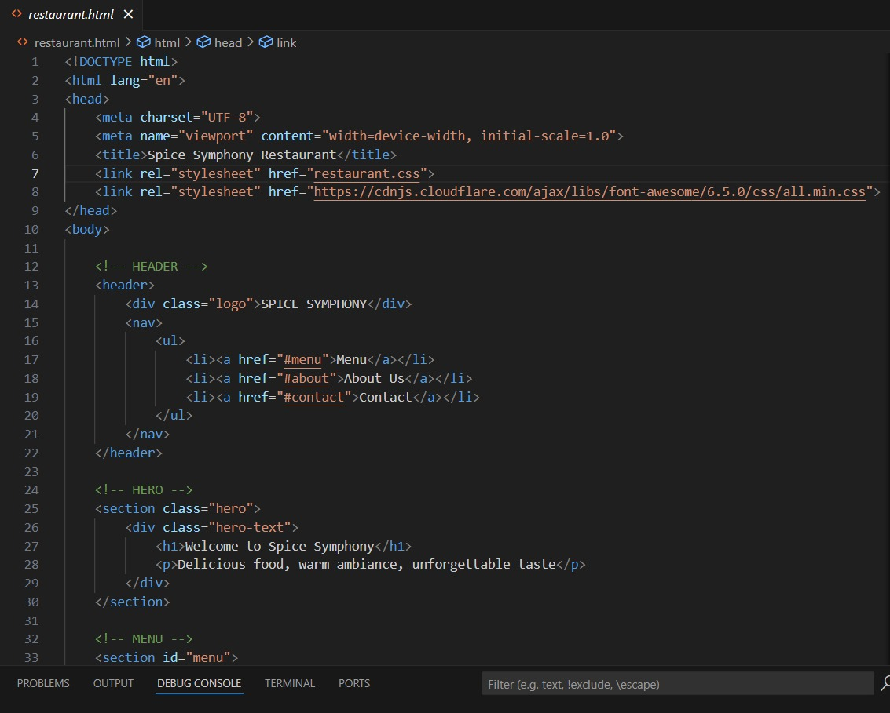

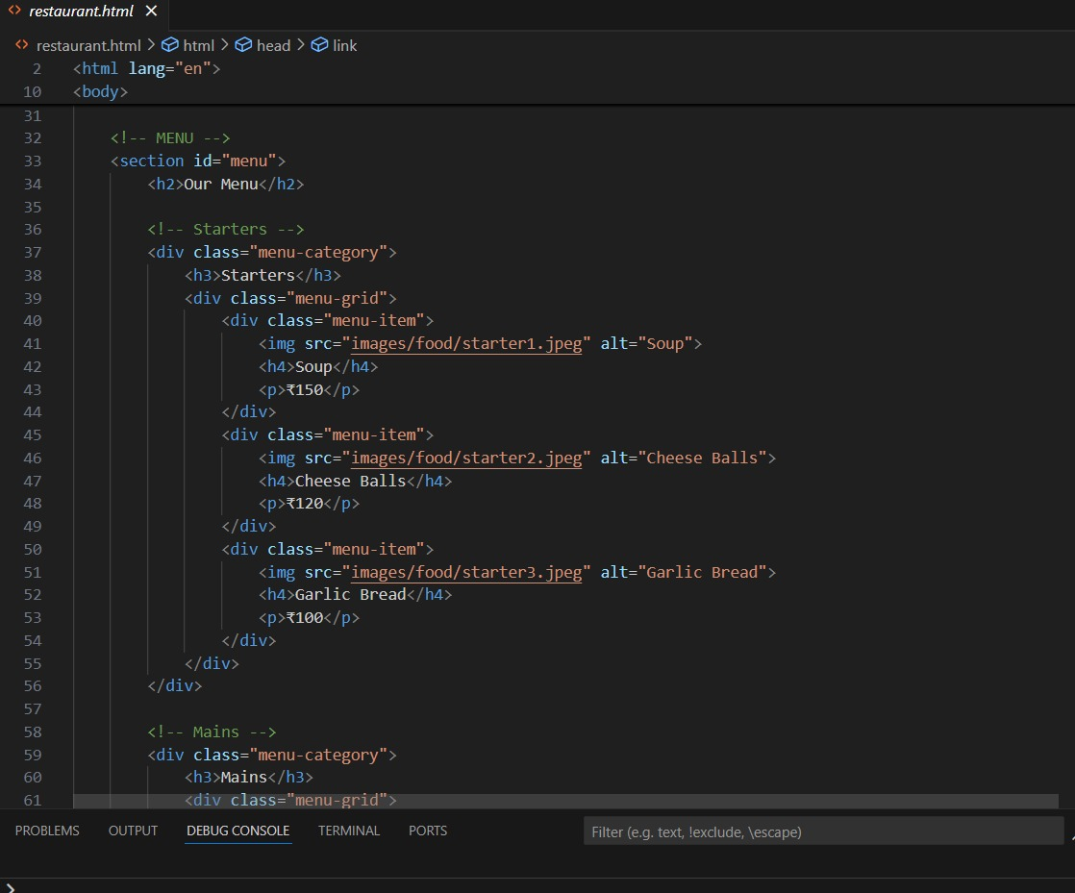

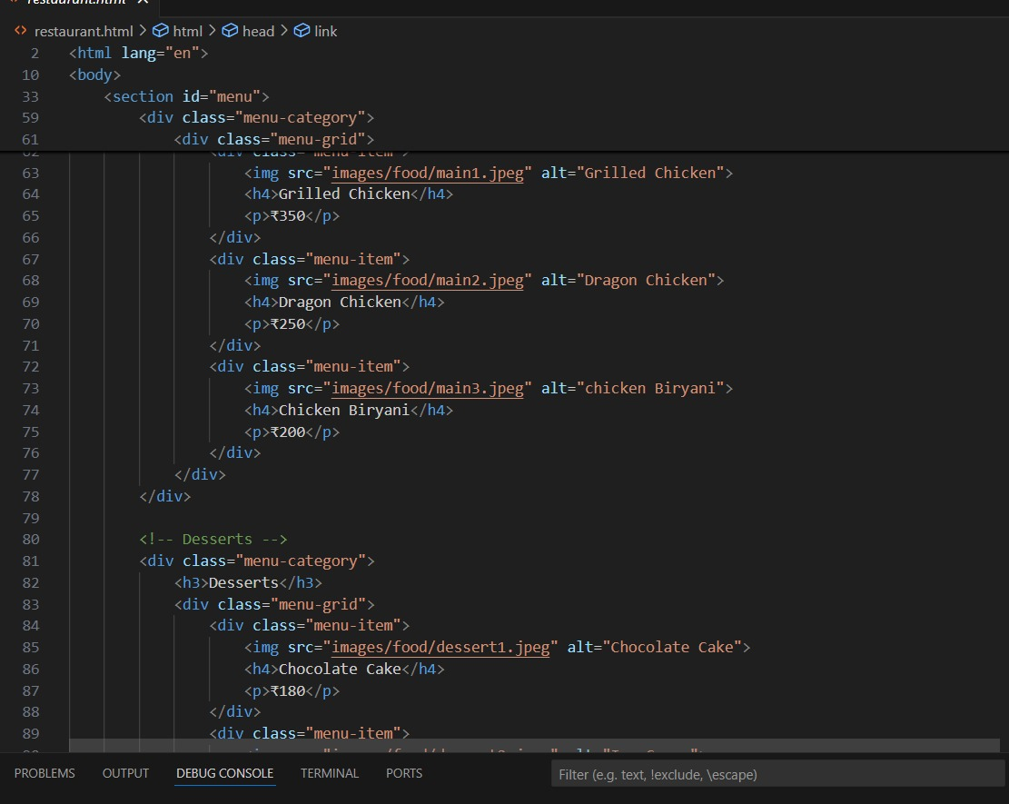

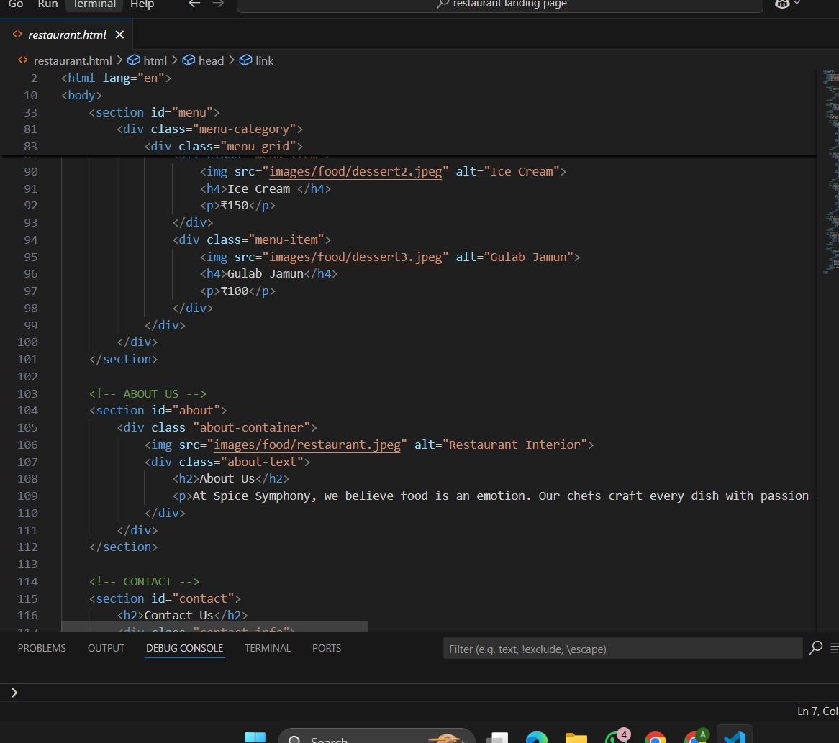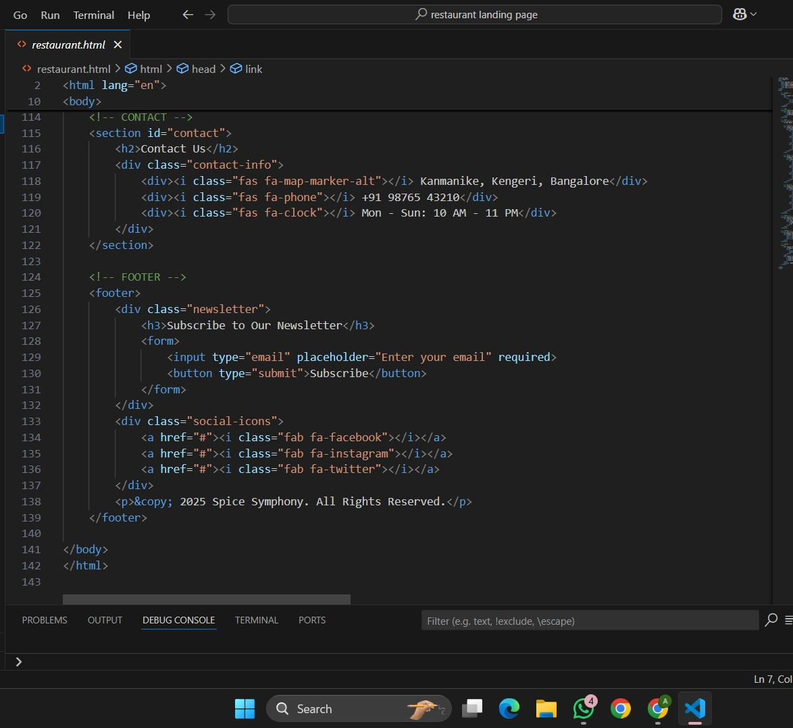

**Screenshot of Final Output**

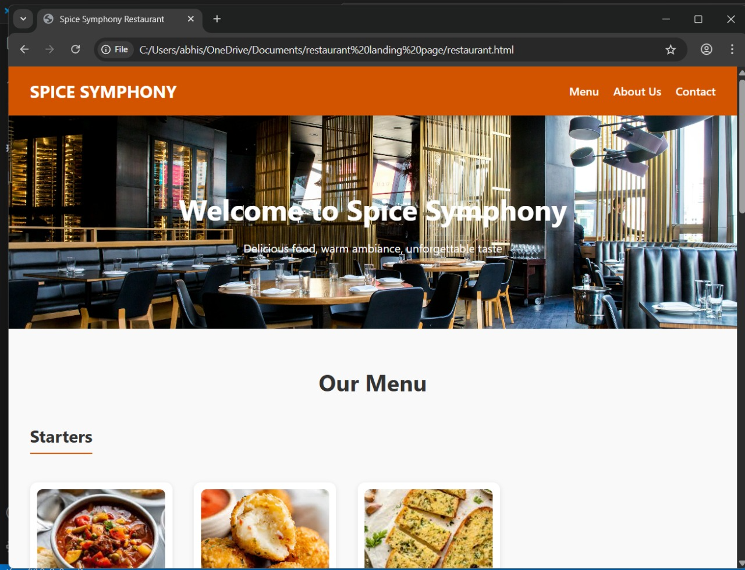

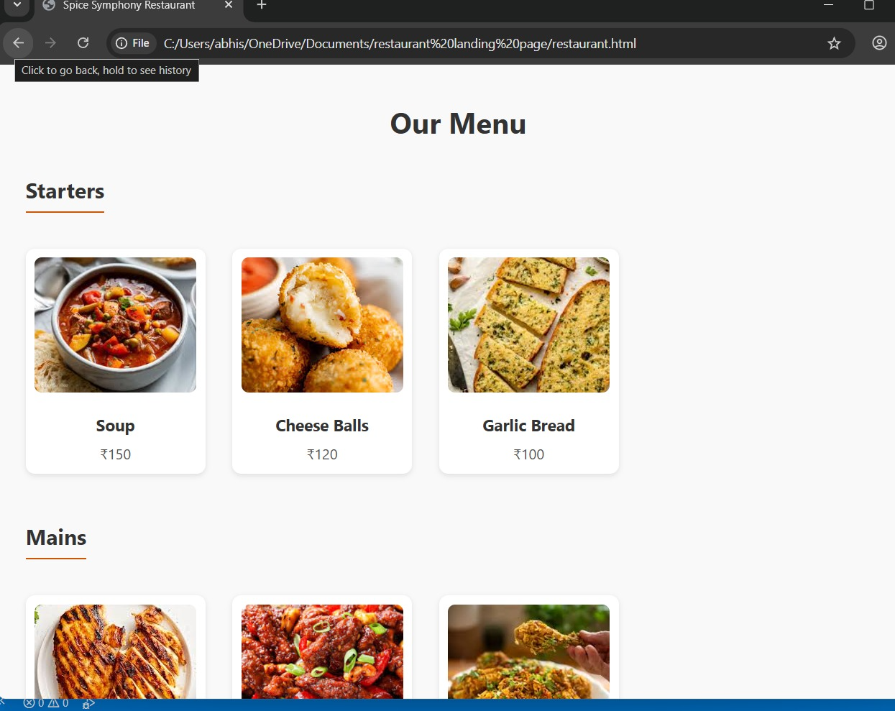

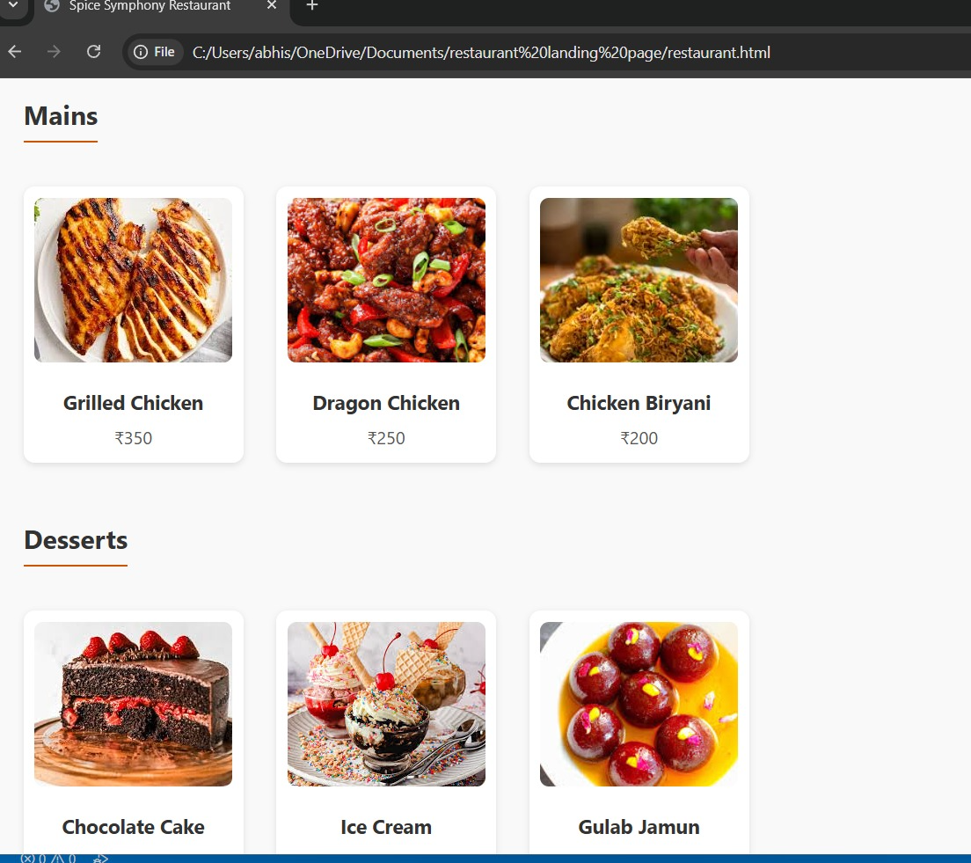

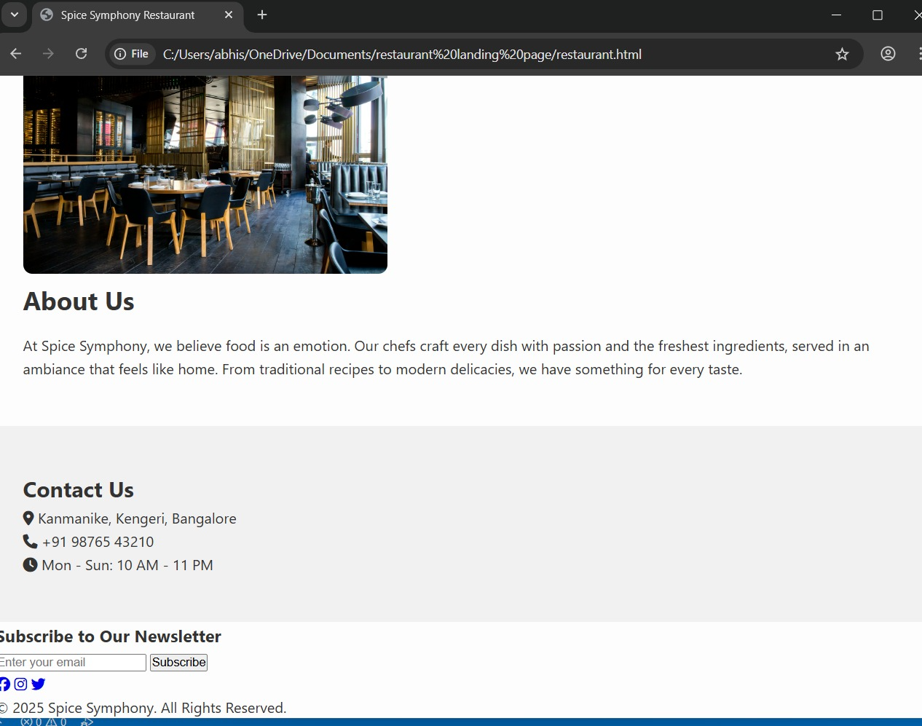

**Conclusion**

The Restaurant Landing Page project demonstrated the importance of aligning design with brand identity. It served as a practical exercise in HTML5 and CSS3, focusing on responsive design, layout composition, and user engagement through visual elements.

**References**

- L&T LMS: https://learn.lntedutech.com

Sensitivity: LNT Construction Internal Use